**Balam Indira Priyadarsini**

**Bridge course Assignment-Day 3**

**Session 1:**

**Countdown**

**Problem Statement:** Print numbers from 10 to 1,then “Blastoff!”

**Algorithm:**

1. Start from number 10.

2. Loop down to 1, decrementing by 1 each time.

3. Print each number in the loop.

4. After the loop ends, print “Blastoff!”

**Pseudo Code:**

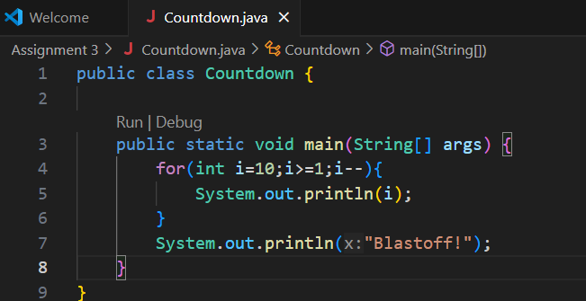

**Output:**

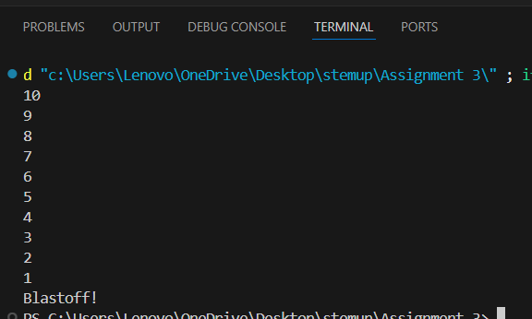

**Testcases:**

|  |  |  |
| --- | --- | --- |
| **Test Case no** | **Input range** | **output** |
| Tc1 | 10 to1 | 10 9 8 7 6 5 4 3 2 1 Blastoff! |
| Tc2 | 5 to 1 | 5 4 3 2 1 Blastoff! |
| Tc3 | 1 to 0 | 1 Blastoff! |

**Sum Until Zero**

**Problem Statement:** Ask user for numbers repeatedly until they enter 0.Sum and print the total.

**Algorithm:**

1. start the program
2. Ask user to enter number
3. Add the number to sum
4. Stop when the number is equal to 0
5. Print the sum value

**Pseudo Code:**

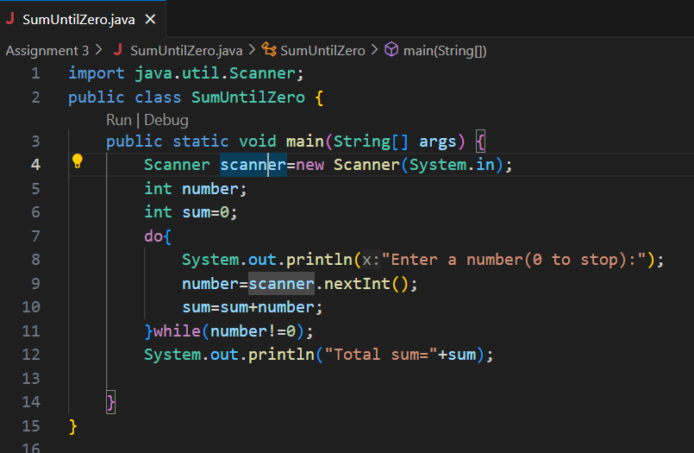

**Output:**

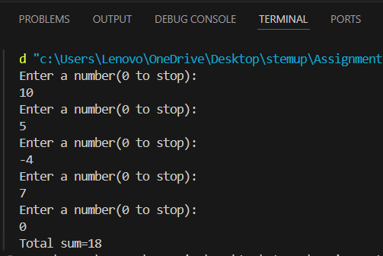

**Testcases:**

|  |  |  |
| --- | --- | --- |
| **Test Cases no** | **Input values** | **Output** |
| **Tc1** | **10,5,-4,7,0** | **Total sum=18** |
| **Tc2** | **0** | **Total sum=0** |

**Guess the Number**

**Problem Statement:**Generate a random number between 1 and 10.Ask user to guess.Provide feedback and loop until correct.

**Algorithm:**

**Pseudo Code:**

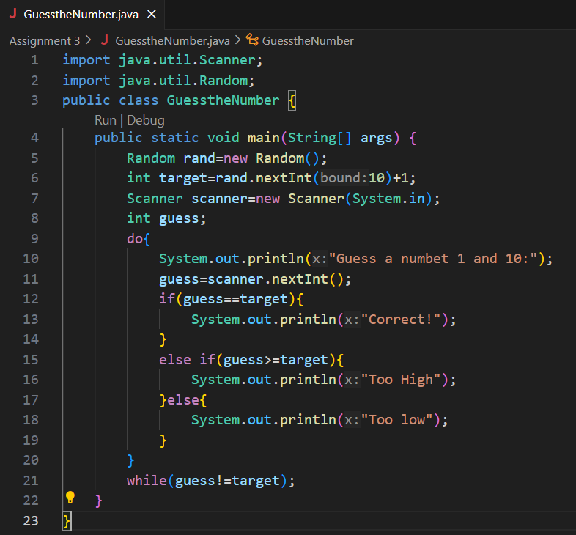

**Output:**

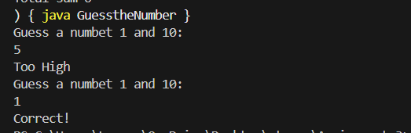

**Testcases:**

|  |  |  |  |
| --- | --- | --- | --- |
| **Test case no** | **Random number** | **User guesses** | **Expected output** |
| 1 | 1 | 5,1 | Too High,correct |
| 2 | 7 | 4,8,6,7 | Too low,Too high,Too low,correct |
| 3 | 4 | 7,4 | Too High,correct |

**Infinite Loop Debugging**

**Problem Statement:** Analyze and fix:

Int counter=0;

While (counter<5){

System.out.println(“Hello”);

}

**Algorithm:**

1. Start a program
2. Check the initial counter to
3. While counter<5 ,Print “Hello”
4. And increment the counter by 1
5. Stop the counter when it reaches 5

**Pseudo Code:**

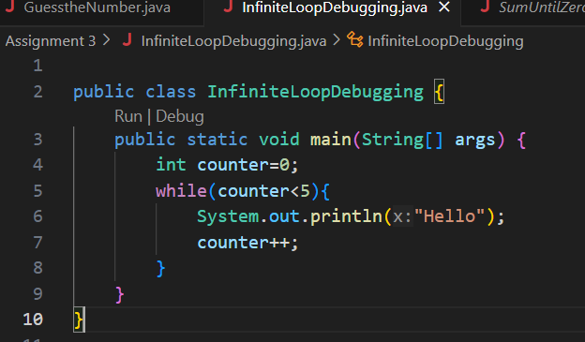

**Output:**

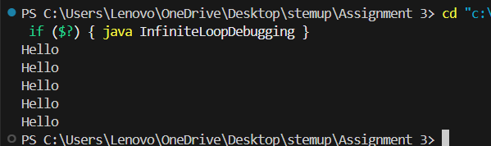

**Testcases:**

|  |  |  |
| --- | --- | --- |
| **Test case no** | Initial counter | Output |
| 1 | 0 | “Hello” print 5 times |
| 2 | 3 | “Hello” print 2 times |
| 3 | -2 | “Hello” print 7 times |

**Section 2:**

**Even Numbers:**

**Problem Statement:**­print even numbers from 2 to 20 using a for loop.

**Algorithm:**

1. Start a program with loop variable from 2.
2. Continue the loop upto the value less than equal to 20.
3. Increment the variable by 2 to get even number
4. Print the variables
5. End the loop when the condition fails

**Pseudo Code:**

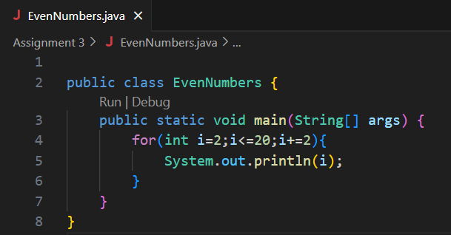

**Output:**

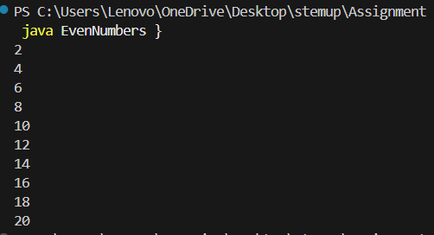

**Testcases:**

|  |  |  |
| --- | --- | --- |
| **Test case no** | Range | Output |
| 1 | 2 to 20 | 2 4 6 8 10 12 14 16 18 20 |
| 2 | 10 to 20 | 10 12 14 16 18 20 |
| 3 | -6 to 8 | -6 -4 -2 0 2 4 6 8 |

**Factorial calculator**

**Problem Statement:** Calculate n! for user input n. Handle edge case when n==0.

**Algorithm:**

1. Start a program by enter a number
2. If n==0,it should return as 1
3. Initialize the variable fact to 1
4. Used for loop from 1 to n values
5. This will multiply fact by loop variable
6. After loop display fact as the result

**Pseudo Code:**

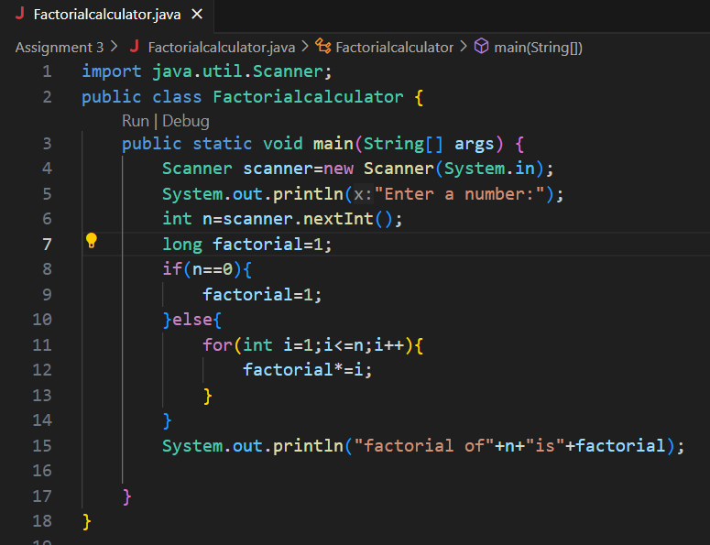

**Output:**

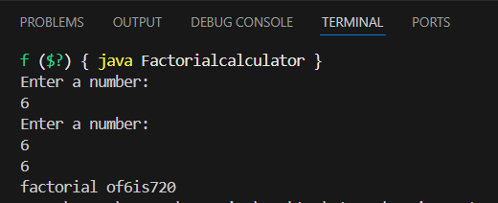

**Testcases:**

|  |  |  |
| --- | --- | --- |
| Test case | Input | Output |
| 1 | 6 | Factorial of 6 is 720 |
| 2 | 5 | Factorial of 5 is 120 |
| 3 | 10 | Factorial of 10 is 3628800 |

**Count ‘a’ in String**

**Problem Statement:** Ask for a string input. Count how many times ‘a’ or ‘A’ appears

**Algorithm:**

1. Enter a string
2. Initialize a counter to 0.
3. If a character is ‘a’ or ‘A’, increment the counter.
4. After the loop, print the count

**Pseudo Code:**

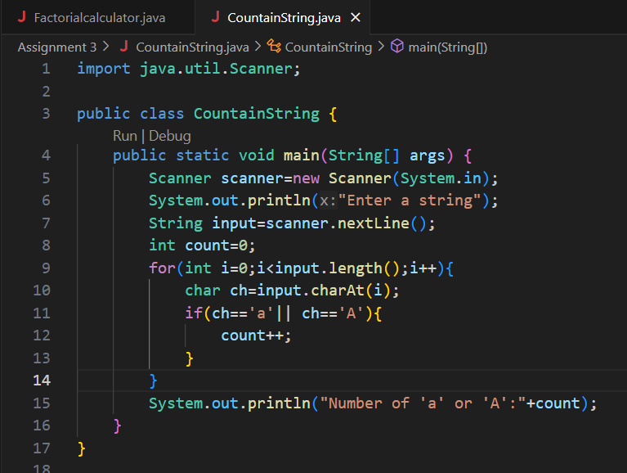

**Output:**

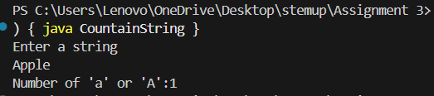

**Testcases:**

|  |  |  |
| --- | --- | --- |
| Test case | Input string | Output |
| 1 | “Apple” | 1 |
| 2 | “Indira” | 1 |
| 3 | “Hello World” | 0 |

**Simple Star Pattern**

**Problem Statement:** Print: ***** using one for loop

**Algorithm:**

1. 1.Use for loop and run for 5 time
2. For each iteration it will print the “*”
3. After the loop end it exits and stop

**Pseudo Code:**

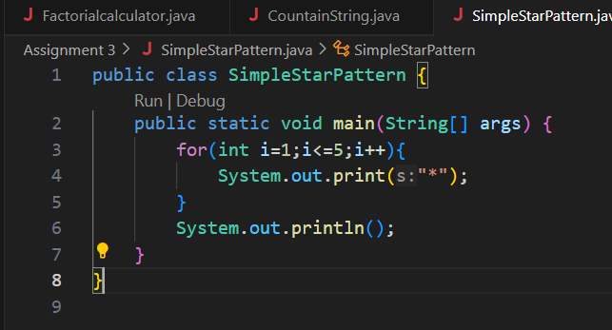

**Output:**

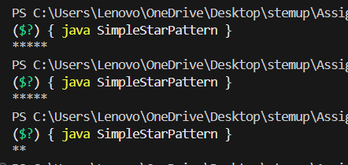

**Testcases:**

|  |  |  |
| --- | --- | --- |
| Test case | Input | Output |
| 1 | 5 | ***** |
| 2 | 2 | ** |
| 3 | 10 | ********** |

**Prime Checker:**

**Problem Statement:** Check if a number is prime using a loop and break.

**Algorithm:**

1. Enter a number as n
2. If n is less than or equal to 1, is not a prim
3. Repeat for i from 2 to n-1
4. If n % i ==0,then it’s not prime and stop the loop
5. If the loop completes without finding a divisor, then n is prime.
6. Print whether a number is prime or not prime

**Pseudo Code:**

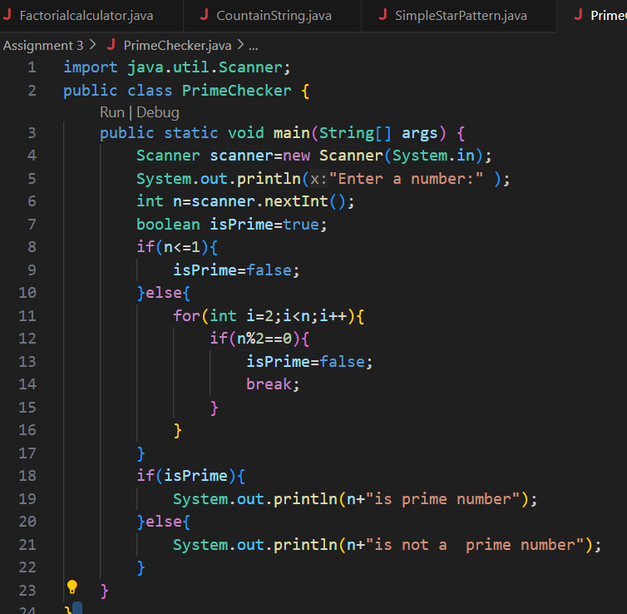

**Output:**

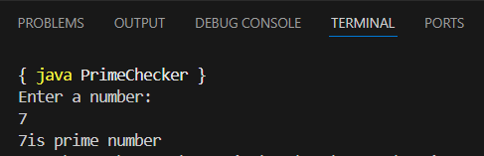

**Testcases:**

|  |  |  |
| --- | --- | --- |
| Test case | Input | Output |
| 1 | 7 | Prime |
| 2 | 5 | Prime |
| 3 | 10 | Not Prime |

**Skip Negatives:**

**Problem Statement:** Input 5 numbers. Use continue to skip negative ones and sum the rest

**Algorithm:**

1. Initialize sum=0 and counter for 5 inputs
2. Take a number as a input
3. If number is negative ,use continue to skip the rest of the loop
4. Add the number to sum
5. After loop print the final sum

**Pseudo Code:**

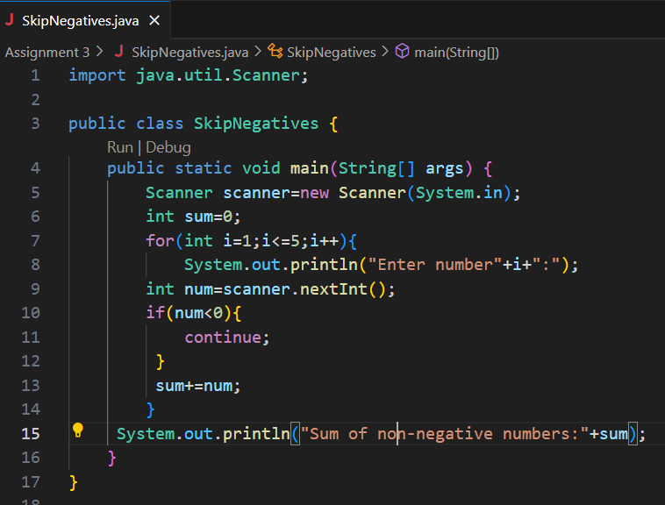

**Output:**

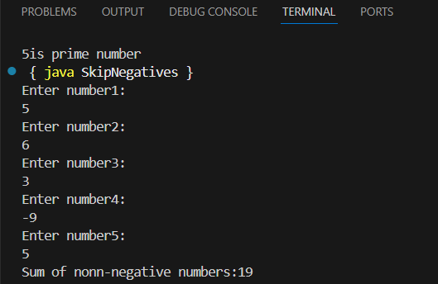

**Testcases:**

|  |  |  |
| --- | --- | --- |
| Test case | Input | Output |
| 1 | 5,6,3,-9,5 | Sum of non-negative numbers:19 |
| 2 | 2, 3, 4, 5, 6 | Sum of non-negative numbers:20 |
| 3 | |  | | --- | |  |  |  | | --- | | 1, -2, 3, -4, 5 | | Sum of non-negative numbers:9 |

**Rectangle Pattern:**

**Problem Statement:** Input rows and columns ,print a rectangle of *.

**Algorithm:**

1. Enter number of rows
2. Enter number of columns
3. Using for loop through each row and column print * with out new line
4. Print one full row and move to next line

**Pseudo Code:**

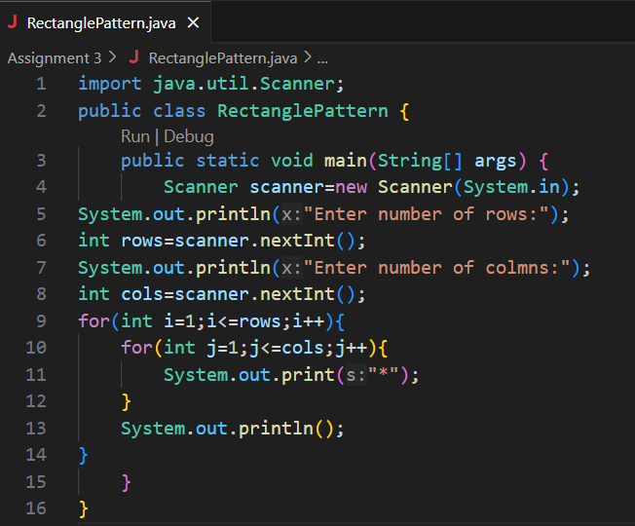

**Output:**

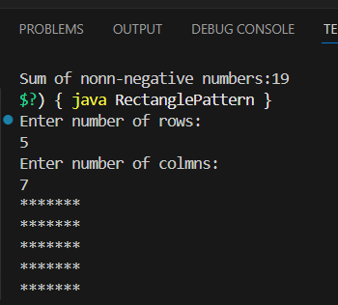

**Testcases:**

|  |  |  |
| --- | --- | --- |
| Test case | Input | Output |
| 1 | 5*7 | 5 rows of 7 stars |
| 2 | 3*5 | 3 rows of 5 stars |
| 3 | 10*6 | 10 rows of 6 stars |

**Triangle Pattern:**

**Problem Statement:** Input height. Print right-angled triangle with *.

**Algorithm:**

1. Enter the height of the triangle
2. Loop from 1 to height by the iteration(row i)print i stars using another loop
3. After printing stars in each rows move to next line
4. Repeat it until the triangle complete

**Pseudo Code:**

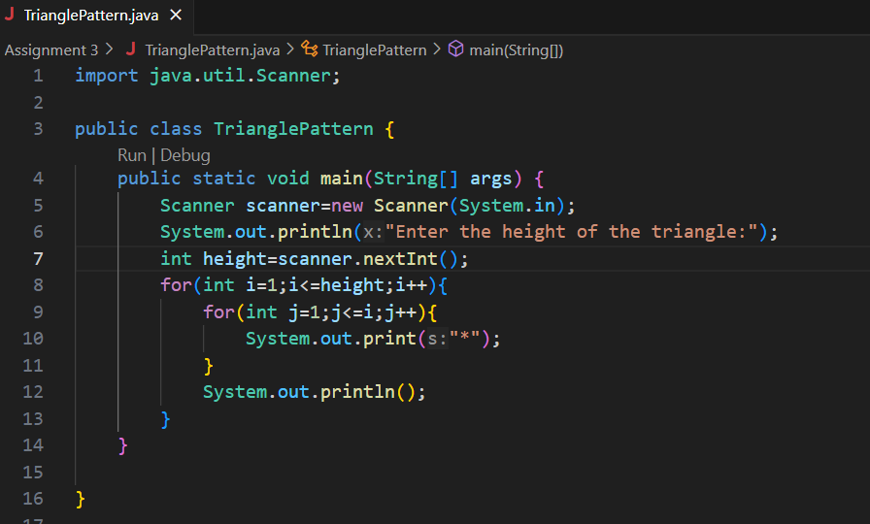

**Output:**

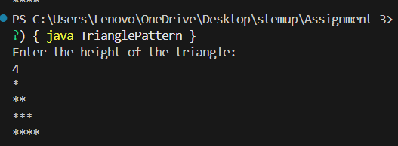

**Testcases:**

|  |  |  |
| --- | --- | --- |
| Test case | Input height | Output |
| 1 | 0 |  |
| 2 | 3 |  |
| 3 | 10 |  |

**Pyramid Pattern Challenge:**

**Problem Statement:**Input height.print centered pyramid.

**Algorithm:**

1. Ask the user for the height of the pyramid.
2. Loop from 1 to height (row-wise):
3. Print (height - i) spaces.
4. Print (2 * i - 1) stars.
5. Move to the next line.
6. End the loop.

**Pseudo Code:**

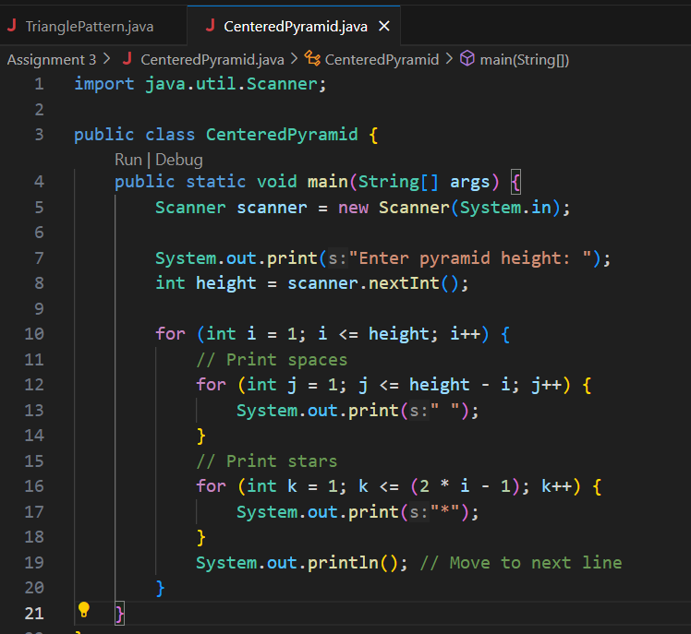

**Output:**

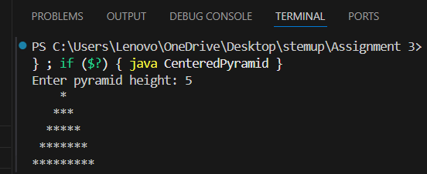

**Testcases:**

|  |  |  |
| --- | --- | --- |
| Test case | Input | Output |
| 1 | 6 |  |
| 2 | 5 |  |
| 3 | 10 |  |

**Code Duplication:**

**Problem Statement:** Write how you would print “Hello!” 10 times without loops.Reflect on how loops make this easier for 1000 times.

**Algorithm:**

1. Write the System.out.println("Hello!"); statement 10 times manually.
2. End program.

**Pseudo Code:**

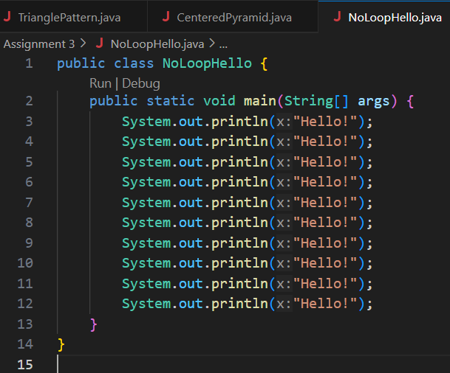

**Output:**

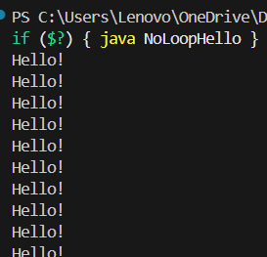

**Testcases:**

|  |  |  |
| --- | --- | --- |
| Test case | Input | Output |
| 1 | 10 | 10 lines of "Hello! |
| 2 | 5 | 5 lines of "Hello! |